Chapter 13 Interfaces and Inner Classes

interface:
- an interface contains method headings and constant definitions only, no instance variables, no concrete methods
- Java should do mutiple inheritance through interfaces
- all method headings be public
- to implement an interface…
  - concrete class must implement all the method headings in the interface
  - concrete class needs to include “implements Interface_Name” in the class declaration
- 多重繼承會出問題，例如B和C繼承A，D繼承B和C，D在執行override method的時候不知道要用哪一個版本
- implements, extends傻傻分不清楚？
  - abstract class/class extends abstract class/class
  - abstract class/class implements interface
  - interface extends interface
  - interface implements abstract class/class (不存在，因為interface不實作)

- for example

interface:
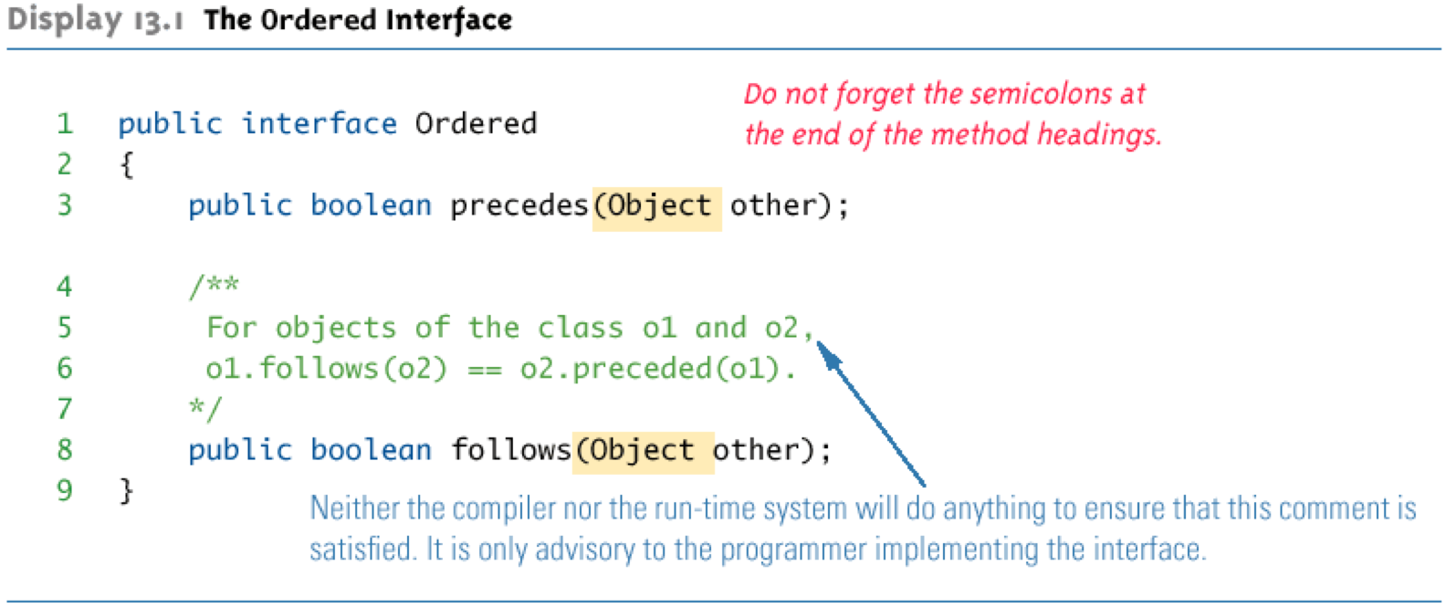

class implements interface:
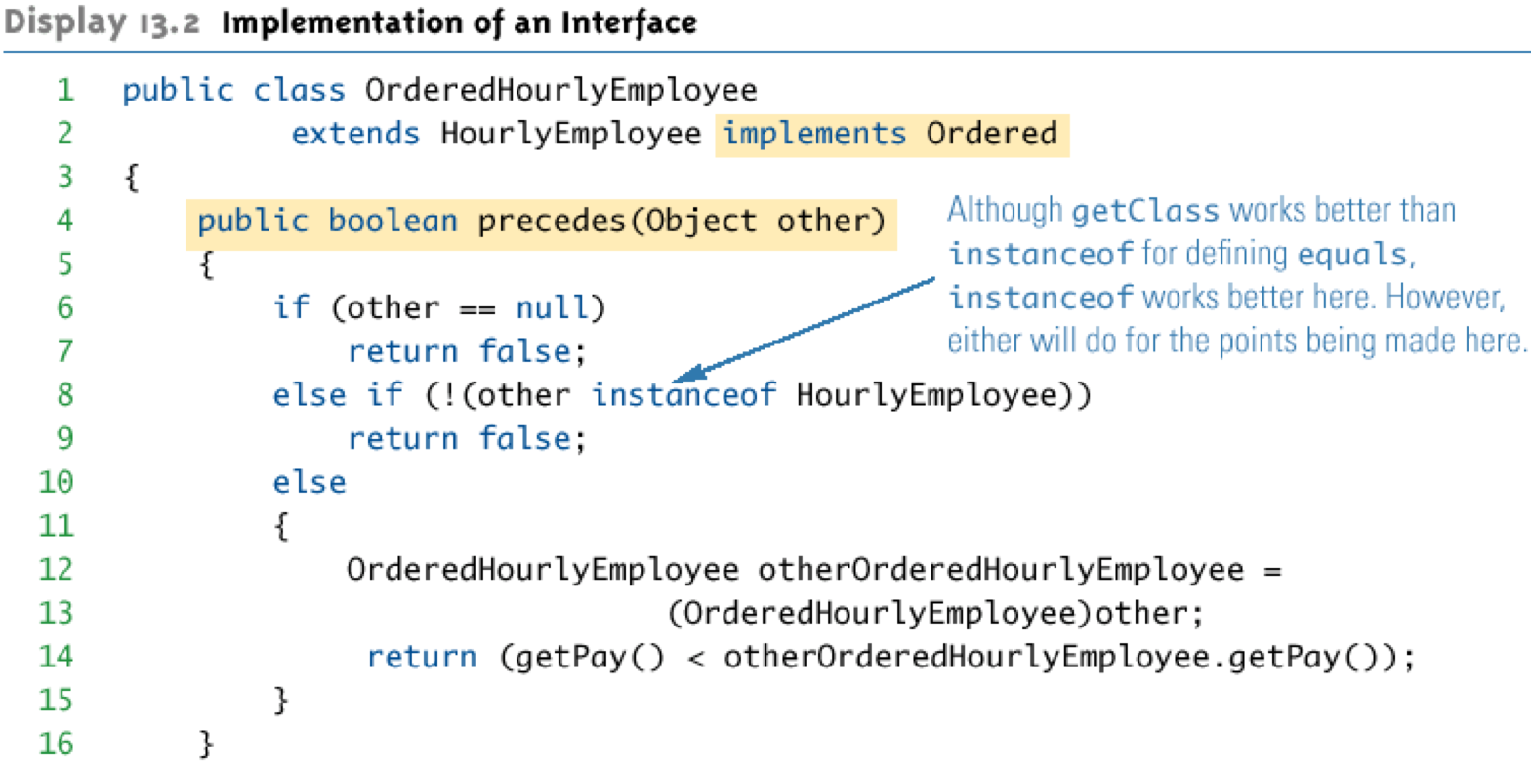
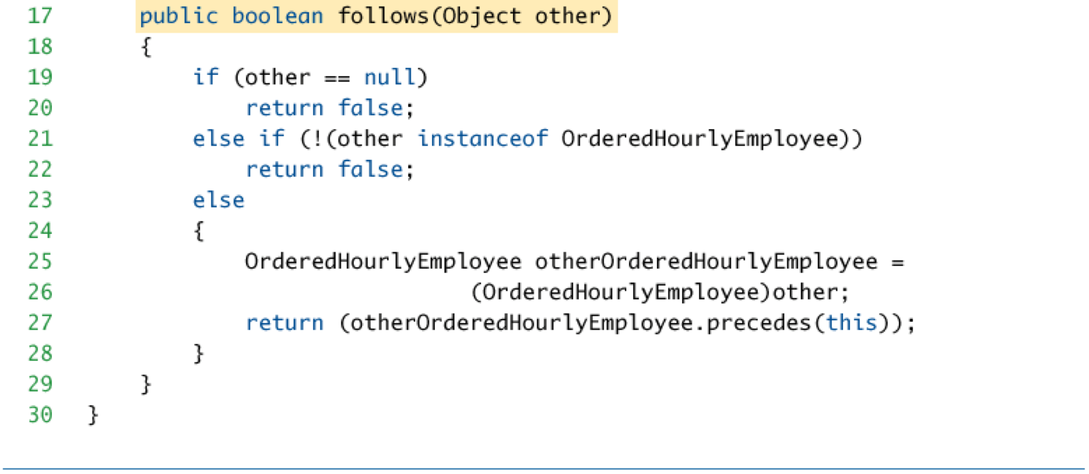

abstract class implements interface:
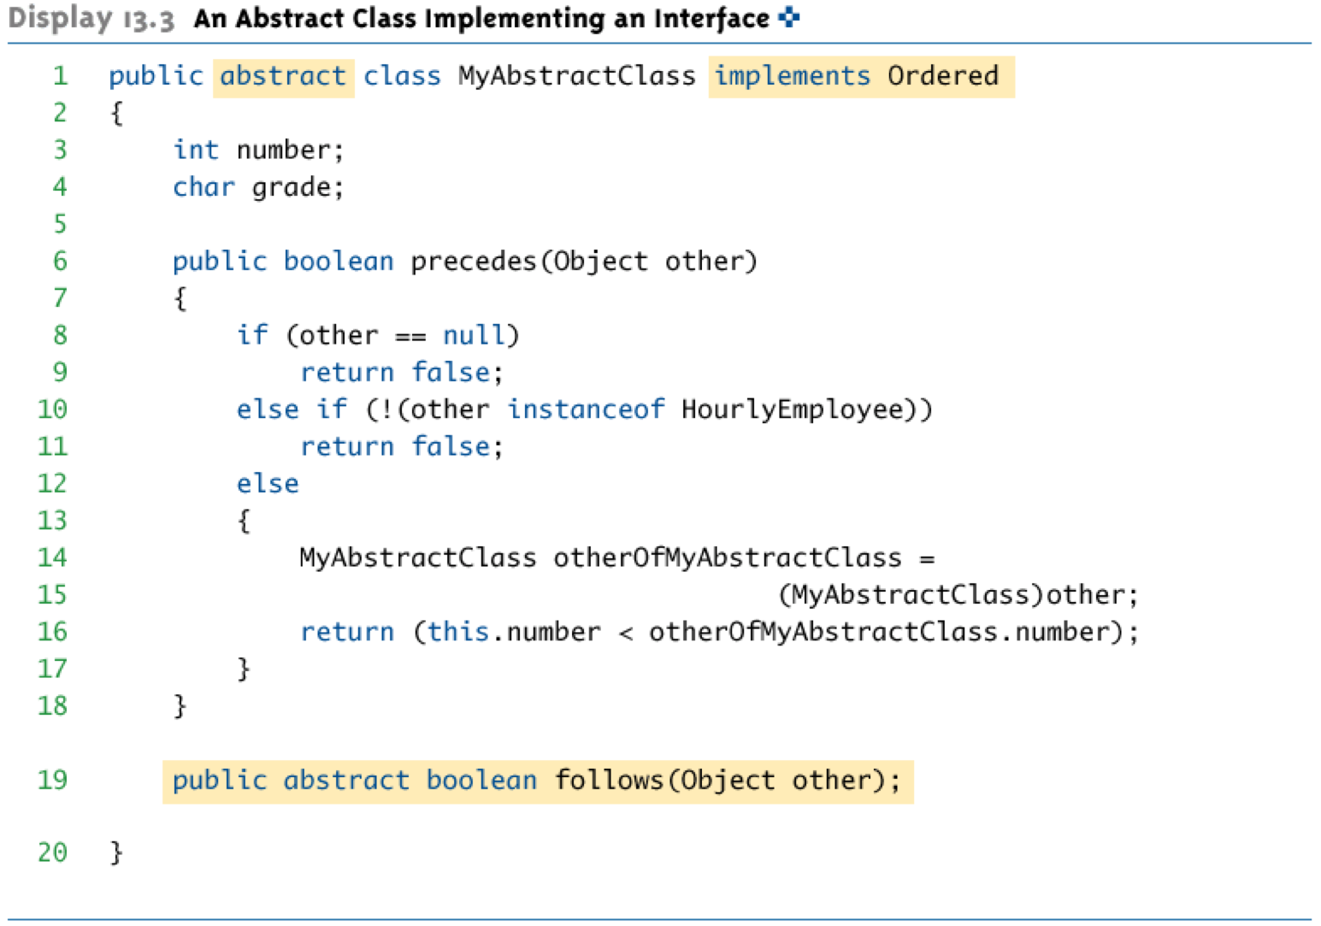

interface extends interface:
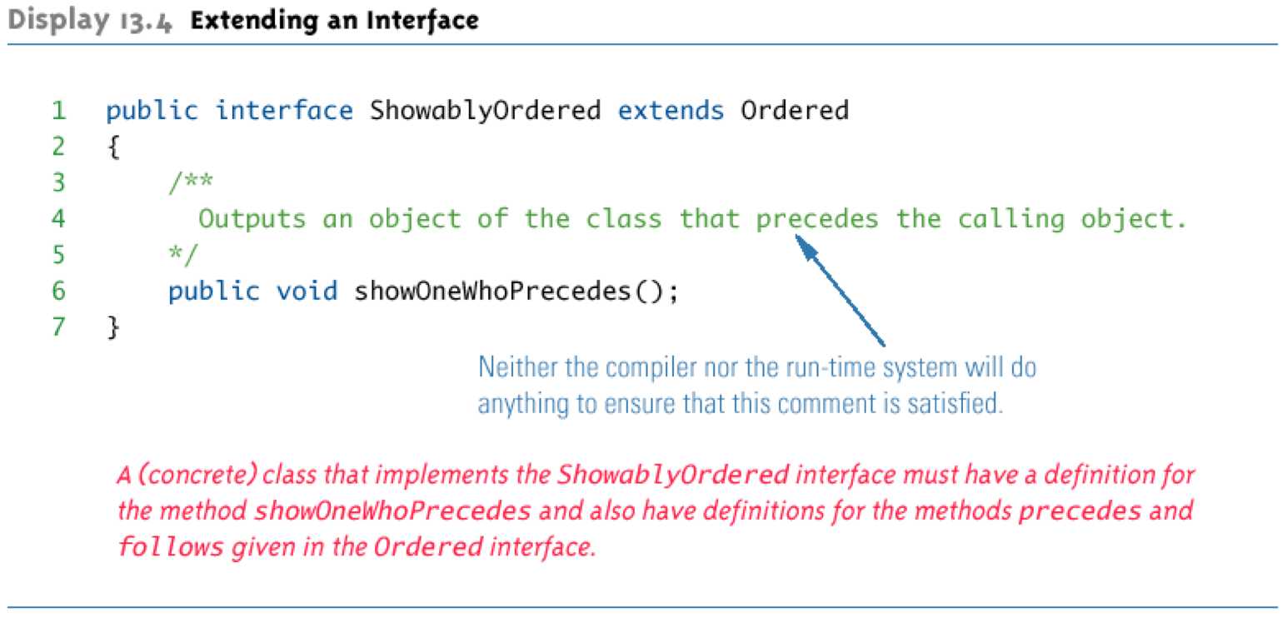

- Comparable Interface
  - in java.lang package
  - all Wrapper class has Comparable interface
  - Comparable has only one method heading:

/** returns a negative number if the calling object “comes
before” the parameter

returns zero if the calling object “equals” the
parameter

returns a positive number if the calling object “comes
after” the parameter
*/
public int compareTo(Object other)

  - 宣告interface的地方必須要打上註解，因為在interface內沒有實作出來，所以需要註明如何讓繼承者使用
  - for example: GeneralizedSelectionSort class，它負責接收Comparable類型的reference

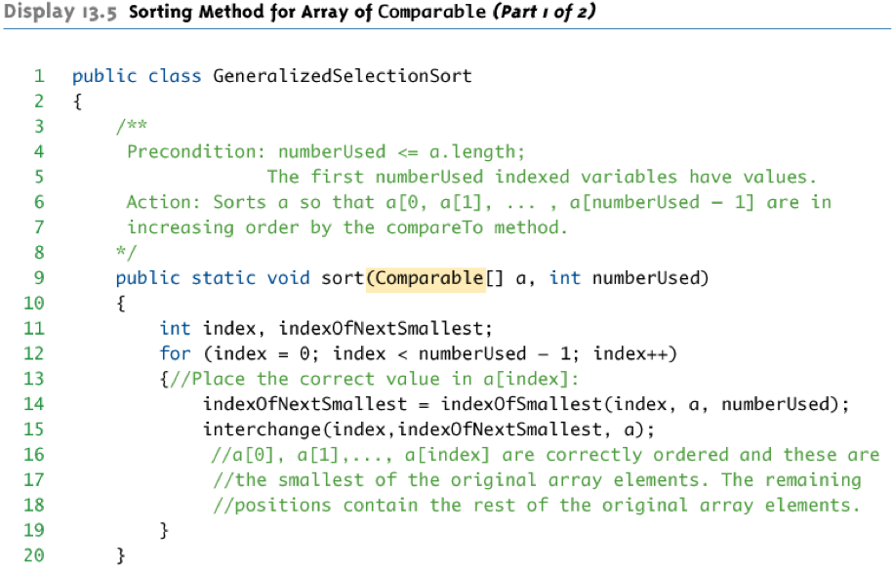
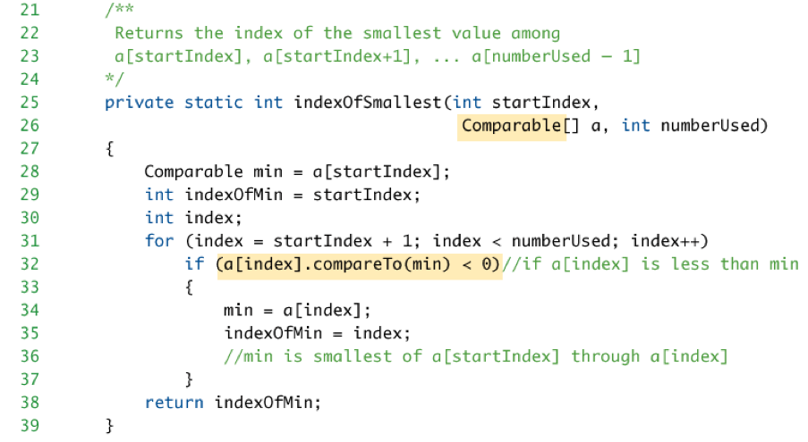
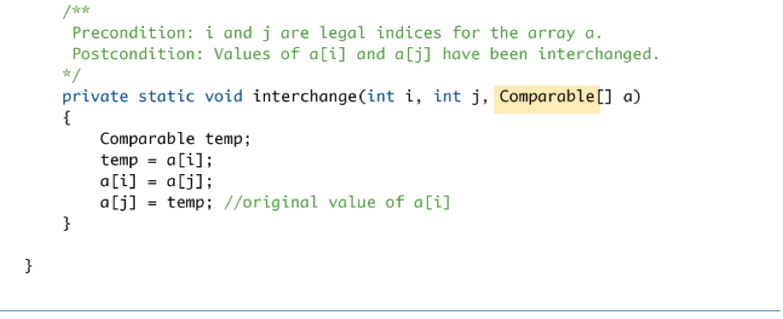

使用GeneralizedSelectionSort的方法：

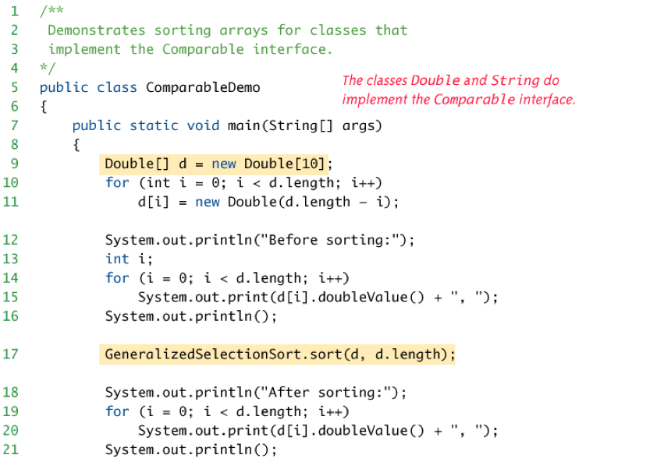
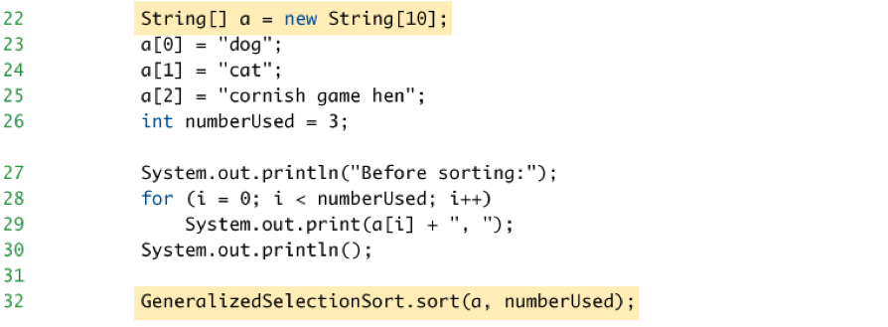
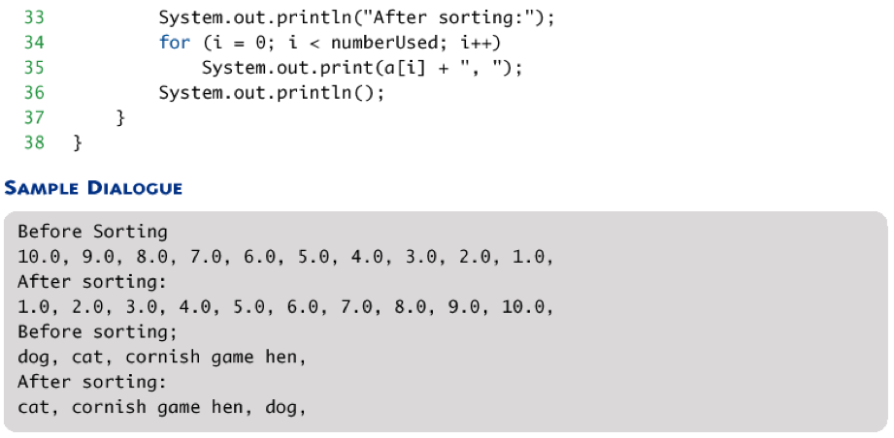


- 當一個interface沒有method headings也無constants（completely empty），其用途僅作分類、標記，例如：
  - Serializable Interface
  - Cloneable Interface：
    - 所有繼承Object class都有的clone，但是不一定有被override。若想要標示有override clone method，可以implement Cloneable interface。所以Cloneable interface是用來指示clone method是否有被使用
    - (以後才會回來看exception)

Inner Classes：
- inner class is a member of the outer class
- if inner class is private, then outside the outer class is unaccessable to inner class
- advantage:
  - inner class can be hidden
  - inner class can be used as helping class
- inner and outer classes have access to each other’s private members, for example:
public class Outer{
private int x1;
private int x3;
private void m1(){
Inner inRef = new Inner();
inRef.x2 = 1; //private member access
}
private class Inner{
private int x2;
private int x3;
private void m2(){
x1 = 2; //private member access
x3 = 3; //自己的x3
Outer.this.x3 = 4; //Outer private access
}
}
}
- Java produces a .class file for any class named ClassName.class for outer class and ClassName$InnerClassName.class for inner class
- static inner class
  - instance variables of the outer class cannot be referenced
  - nonstatic methods of the outer class cannot be invoked
- public inner class
  - can be used outside of the outer class
  - 宣告方法：
OuterClass.InnerClass inObject=new OuterClass.InnerClass()
- derived inner class is allowed, for example
public class Outer{
private int x1;
private int x3;
private void m1(){
Inner inRef = new Inner();
inRef.x2 = 1; //private member access
}
private class Inner extends Outer{
private int x2;
private int x3;
private void m2(){
x1 = 2; //private member access
x3 = 3; //自己的x3
Outer.this.x3 = 4; //Outer private access
}
}
}
//Inner class即包含了Outer class所有的data member和member function

- Anonymous Class
  - temporary use of class
  - class definition is embedded inside the expression with the new operator
  - for example:
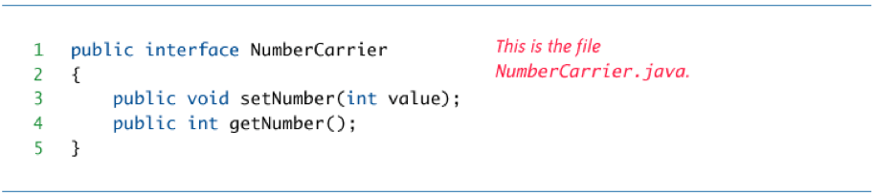
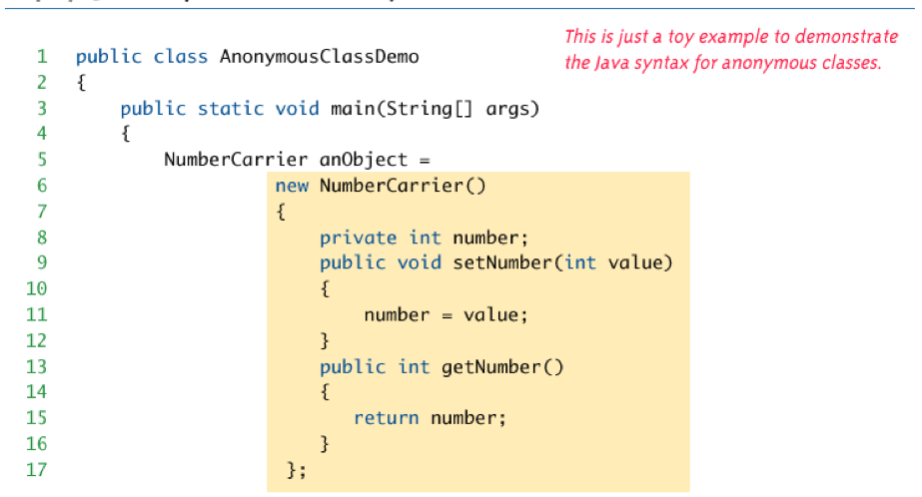
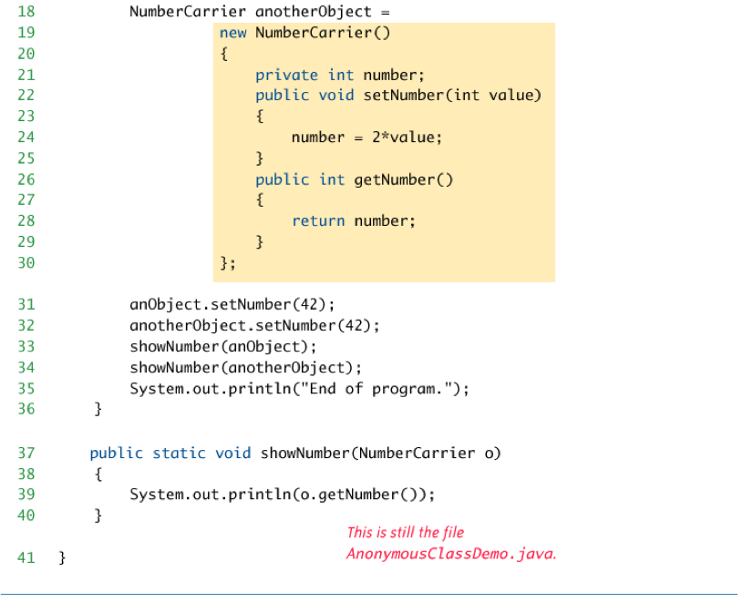

- inner class規則
  - interface內不可有inner class (因為interface不實作東西)
  - interface內可有inner interface
  - class內可有inner abstract class
  - class內可有inner interface
  - abstract內可有inner class
  - abstract內可有inner interface

